Practical 1 : Demonstration of create database

Name : Divya Patil

Batch no :4 roll.no : 103 div : A

*****************************************************************************************

create database priyaa;

use priyaa;

**OUTPUT:**

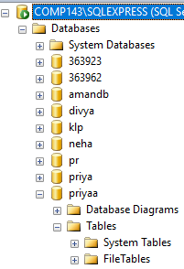

**Practical 2 : Create table insert 10 records in it.**

**Name : Divya Patil**

**Batch no :4 roll.no : 103 div : A**

create database priyaa;

use priyaa;

create table priyaa (ID int,SNAME varchar(60),SADD varchar(20))

insert into priyaa (ID,SNAME,SADD) values(100,'priyanka','fybca');

insert into priyaa (ID,SNAME,SADD) values(101,'harshu','fybca');

insert into priyaa (ID,SNAME,SADD) values(102,'himakshi','fybca');

insert into priyaa (ID,SNAME,SADD) values (103,'harshal','fybca');

insert into priyaa (ID,SNAME,SADD)values (104,'kunal','fybca');

insert into priyaa (ID,SNAME,SADD) values (104,'kejal','fybca');

insert into priyaa (ID,SNAME,SADD) values (105,'ketan','fybca');

insert into priyaa (ID,SNAME,SADD) values (106,'bhumika','fybca');

insert into priyaa (ID,SNAME,SADD) values (107,'hitesh','fybca');

select *from priyaa;

OUTPUT:

